Data Analysis Report[Netflix, Movies and TV shows]

OBJECTIVE
In this project report we are aimed to analyze the given dataset and firstly find all of the content populalrity trend and then answer few questions like content changed over the time and countries produced the most shows.

Data cleaning:
This step involves cleaning the data to make it more reliable and efficient for training machine learning models and performing data analysis. The process is carried out in several steps, as outlined below:
Step 1: I reviewed each column individually to determine whether a particular feature was relevant to our analysis. If it was important, I identified how to extract or use the required information effectively. I also created a planner in the form of a flowchart to guide the entire analysis process.
Let’s get into it:
- First column is ‘Show id’, this column contains all unique values which makes it unusable.
- Then comes ‘type’ column, this column is useful since we have to find which country produced most shows that will be excluding movies.
- Third column is title, it is not relevent to our at all and lowkey it is unique too.
- The fourth columns is director, this column is also irrelevent since no a single question is related to this.
- Fifth column is very cruicial since our whole analysis revolves around countries.
- Then we gone through the columns ‘date added’, ‘duration’ and ‘description’ these columns are also not needed since our goals does not rely on them.
- Then the column come is ‘rating’, this column is important since we have to fing the trend change in ratings over the years which is included in content popularity trends.
- At last there were two columns ‘listed in’ and ‘released year’, they both are important since with ‘listed in’ column we have to find ‘which genr is most important’ and ‘region wise genr’, the ‘released year’ column is important because we have to find ‘content channged over the time’ and ‘Trend change in ratings over the years‘.
Step 2: After identifying which features were important, the next step was to remove the irrelevant ones.
- Then, I checked each remaining column for missing or null values one by one with the use of [df.isnull().sum()] and I found In this dataset, the ‘country’ column contained 831 missing values.
- Instead of removing these rows which might negatively impact the accuracy of our analysis so I filled the missing entries with the label “Others.”

EDA[Exploratory Data Analysis]:
This step involves a deeper analysis of the dataset to extract meaningful insights by progressively applying logical approaches based on initial observations and functions available in pandas.

Step 1: Initial Overview and Understanding
We started by examining the dataset's structure and key statistics to build an intuition for the data:
- Displayed the first and last six rows to understand how the data is stored.
- Used .shape to check the dataset dimensions.
- Applied the describe() function to understand basic statistical measures such as mean, count, and frequency distributions.
This gave us a foundational understanding and hinted at potential areas where filtering and grouping could uncover valuable insights.

Step 2: Grouping to Dig Deeper
After the initial overview, it became clear that using the groupby() function would allow us to uncover patterns by aggregating the data meaningfully. This logical step came from realizing that many insights could be derived by grouping the data based on specific columns such as release year, genre, and country.
Insights derived:
- Most Common Genre Over the Years
  - Grouping the data by genre and release year, then applying .count() helped us identify that the most frequently produced genres are “Dramas, International Movies.”
- Country-wise Production Count by Year
  - Similarly, grouping by country and release year, and applying .count() showed that the United States consistently tops the list in terms of content production.
This logical grouping helped isolate trends that would have otherwise been hidden in the raw data.

Step 3: Leveraging Value-Based Functions for Trend Analysis
Since grouping yielded strong insights, the next logical extension was to use simpler yet powerful functions like value_counts() and sort_values() to analyze frequency distributions and rank content attributes such as country, genre, and type.
Here’s the reasoning and what we found:
- Finding the Country with Most Content
  - Realizing that grouping was effective, it struck that directly applying value_counts() on df['country'] would give a quick count of content per country.
  - To make the result more readable, we chained it with .sort_values():
python
CopyEdit
df['country'].value_counts().sort_values(ascending=True)
  - Result: United States emerged as the top content-producing country.
- Most Frequently Produced Genre
  - Building on the same idea, applying value_counts() on the genr column showed that “Dramas, International Movies” appear most frequently.
  - This led us to the logical conclusion that these genres are likely highly popular due to greater viewership appeal.
- Movies vs TV Shows – Which is More Popular?
  - Here, a simple thought emerged: if we just count how many entries are labeled as "Movie" vs "TV Show," we’d get a basic but strong insight into content format preference.
  - So, we used:
python
CopyEdit
df['type'].value_counts()
  - Result: Movies are more frequently created and likely more watched than TV Shows.

Step 4: Exploring Regional Genre Preferences
A very interesting idea came up during the analysis:
“What if we could identify which genres are most popular in each country?”
This would be crucial for strategic decisions in content production and localization.
However, the challenge was that each cell in the country and genr columns could contain multiple values. To tackle this:
- We used the explode() function to ensure each country and genre appears in a separate row.
- Then, grouped the data by both country and genre to count the frequency of each combination.
Code Block Used:
df_expanded = df_copy.explode('country').explode('genr')
country_genre_count = df_expanded.groupby(['country', 'genr']).size().reset_index(name='count')
country_genre_count = country_genre_count.sort_values(by='count', ascending=False)
Insights Gained:
- India: Most preferred genre is International Movies.
- United States: Documentaries are the most frequently produced genre.
This was a powerful analytical step that came from the thought of regional personalization and the realization that breaking down multi-valued fields is necessary for granular insights.

country | genr | count
1547 | India | International Movies | 807
2391 | United States | Dramas | 429
2389 | United States | Documentaries | 429
1575 | India | Dramas | 404
2386 | United States | Comedies | 374
... | ... | ... | ...
929 | United Arab Emirates | Sci-Fi & Fantasy | 1
925 | United Arab Emirates | Comedies | 1
924 | Ukraine | Documentaries | 1
923 | Ukraine | International Movies | 1
1250 | Canada | TV Sci-Fi & Fantasy | 1

- At last I thought presenting the table showing countries and the genr they produced the most will be a great idea as this will be more convinient way understanding the insight better.
- country genr count
- 526 India International Movies 864
- 1351 United States Dramas 835
- 1300 United Kingdom British TV Shows 225
- 1439 others International TV Shows 223
- 391 France International Movies 207
- ... ... ... ...
- 1066 Slovakia Dramas 1
- 803 Montenegro Dramas 1
- 1074 Somalia Dramas 1
- 164 Burkina Faso Dramas 1
- 0 Dramas 1

PLOT OF COUNTRY AND GENRE:
Visualising the data in a report plays a very vital role and without that our report never get completes, so on the basis of the questions asked only we decided to plot a lineplot showing the country vs genr showing which country have produced which genr the most, since this is one of the major insight any customer will require and wanted see or take a look.
Here, as we have already found that which country have produced which genr the most, so we gonna use that only along with country.
The code block is:
plt.figure(figsize=(14,6))
plt.plot(max_genres_sorted['country'],max_genres_sorted['count'])
plt.xlabel('countries')
plt.ylabel('genres')
plt.tight_layout()
plt.xticks(rotation=90)
plt.legend(loc='upper right')
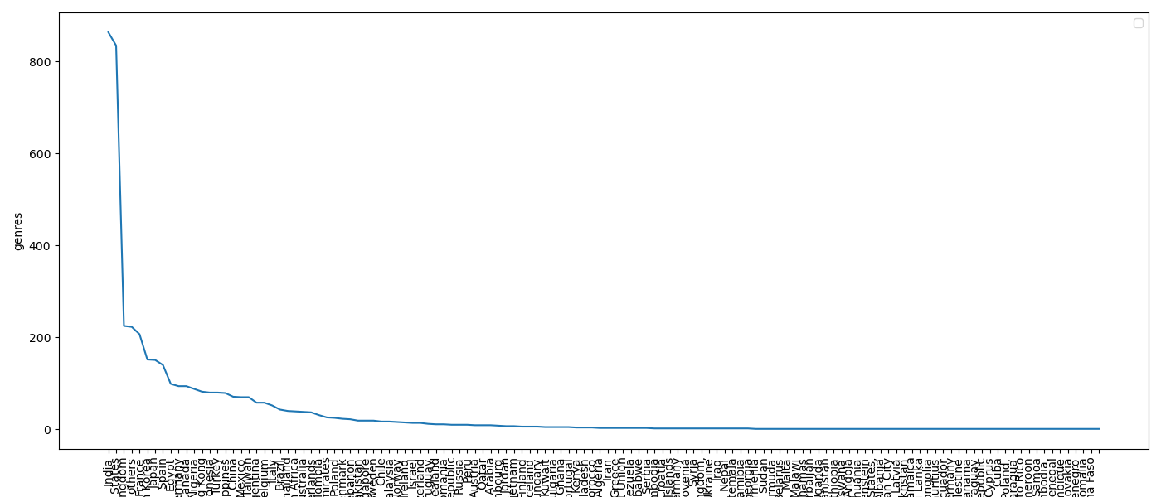
From thise observations, we gained valuable insights into genre preferences across different countries. For example, "International Movies" are the most watched genre in India, while "Dramas" top the charts in the United States. On the other hand, some genres are significantly less popular in certain regions—for instance, "Korean TV Shows" are the least watched in the United States, and "Documentaries" have the lowest viewership in Iran.

PLOT OF RATING AND RELEASE YEAR:
As we were asked to show how the content has changed over the years, and since we only have the release_year and rating columns, we plotted a basic graph to visualize the year ranges during which shows with particular ratings were produced the most.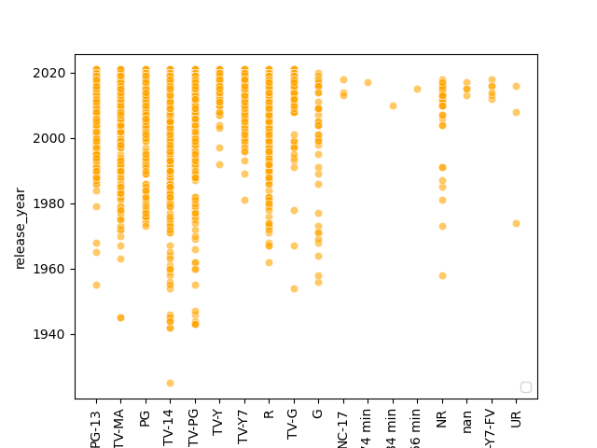

Content Evolution Over Time:
From the plot above, we can clearly observe that TV-14 has been a consistently present rating since the early 1940s and has experienced significant growth in popularity over time. In contrast, durations like 74 min, 84 min, and 66 min appeared only briefly, primarily during the late 2010s, indicating limited production during that period.
How Content Changed Over Time:
The scatter plot reveals that the scope of content has broadened significantly. In earlier decades, ratings like TV-14 and TV-PG—which cater to audiences aged 14+ or those watching under parental guidance—were predominant. However, over time, viewership has expanded to include content rated PG-13 and TV-G, indicating that even adult audiences began consuming content originally meant for younger or family-friendly demographics.
This was a powerful analytical step that came from the thought of regional personalization and the realization that breaking down multi-valued fields is necessary for granular insights.
FEATURE ENGINEERING:
Here there is no need of changing the name of columns since we got all of our answeres without doing this and all the columns of this dataset we need has the apropriate names.

FINAL ANALYSIS:
Content Popularity Trends
- Most Produced Genre:
  - "Dramas, International Movies" is the most frequently produced and watched genre globally.
- Most Watched Type:
  - Movies are watched more than TV Shows.
- Most Active Country:
  - United States produced the highest number of movies and shows.
  - India follows closely, especially with International Movies.
2. Country and Genre Analysis
- Top Genres per Country:
  - India: International Movies (864)
  - United States: Dramas (835), followed by Documentaries (429)
  - United Kingdom: British TV Shows (225)
  - Others: International TV Shows (223)
- Least Popular Pairings:
  - Countries like Slovakia, Montenegro, Somalia, and Burkina Faso have only one entry each, mostly in Dramas.
- Specific Trends:
  - Korean TV Shows are least watched in the United States.
  - Documentaries are least watched in Iran.
3. Change Over Time
- Ratings Over Time:
  - TV-14 rating was present from the 1940s but surged significantly in later decades.
  - Short-duration movies (e.g., 74, 84, 66 mins) only appeared in the late 2010s.
- Audience Broadening:
  - Earlier content was targeted at teen audiences (TV-14, TV-PG).
  - Over time, the audience base expanded to include adults (PG-13, TV-G), suggesting content diversification.
QUESTIONS ASKED:
- Which country has produced the largest number of shows?
Ans. India
- How the content changed over the time?
Ans.
- United states alone have made the largest number of movies among all.
- 'Dramas, International Movies' genr is made the most since it is most watches genr.
- in India 'International' movies are watched the most and in United states 'Documentaries' are watched the most.
- TV-14 is the rating which was kind of constant from the early 1940s and gradually it boomed whereas 74 min, 84 min and 66 min are the three ratings which was never being made except in late 2010s
- content have been broadened over the time as in the earlier times TV-14 and TV-PG that means content for the people above 14 and the content can be watched under the supervison of adults was watched only but gradually the crowd of PG-13 and TV-G i.e adult also started watching.

